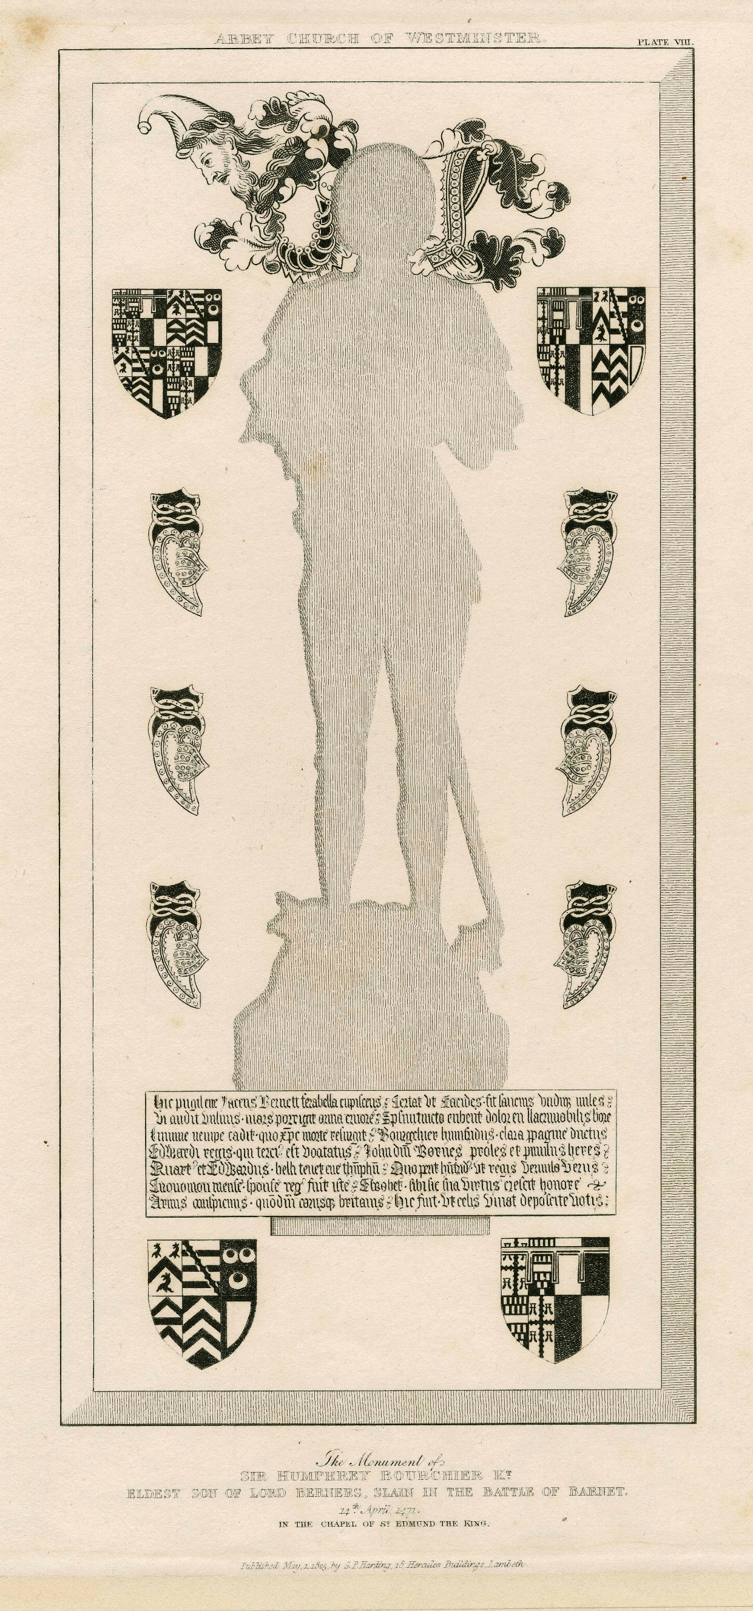
Monuments of the Wars of the Roses
A one-day colloquium in honour of Mark Downing
Saturday 21st October 2023
Guildhall, Guildhall Lane, Leicester, LE1 5FQ

Booking
9.45 Arrival and registration (tea and coffee available)
10.25 Welcome by the President of the Church Monuments Society
10.30-11.30 Session 1: Image
Tobias Capwell, Carnage and Commemoration: Relating Monuments of Late Medieval England to the Military History of the Wars of the Roses
Challe Hudson, Tires, Turrets, Butterflies, or Partlets, What Will the Ladies Put on Next?
11.30-12.00 Tea/coffee break
12.00-1.00 Session 2: Monuments in Yorkist London
Richard Asquith, Commemorating the King’s Men: Knightly Londoners in the Wars of the Roses
Christian Steer, Dead Yorkists in Late Medieval London
1.00-2.15 Lunch (own arrangements)
2.15-3.15 Session 3: Status and Splendour
Madeleine Gray, The Herbert Tombs in Tintern Abbey: Fact, Fiction or Creative Reconstruction?
John Lee, ‘They supported the dignity of their house, and lived in a manner suitable to their splendid descent’: The Brass of William (d.1474) and Elizabeth Fitzwilliam of Sprotbrough (Yorkshire)
3.15-3.45 Tea/coffee break
3.45-4.45 Session 4: Burial and Commemoration
David Lepine, Chantry Chapel as Tomb: The Commemoration of Hugh Sugar (d.1489) at Wells Cathedral
Nicholas Flory, ‘Soror, uxor’: The Burials of Margaret of York, Duchess of Burgundy
4.45 Final remarks by Mark Downing
Please reserve ______ places at a cost of £15 to members (£20 to non-members) making a total of £ _____
Name: __________________________________ Address: ___________________________________
____________________________________________________________________________________
Phone or email: _______________________________________________________________________

Cheques, payable to the Church Monuments Society and the booking form, should be sent to Mrs Sally Henshaw, 28 Lyncroft Leys, Scraptoft, Leicester, LE7 9UW. Alternatively, to pay by bank transfer: CHURCH MONUMENTS SOCIETY; SORT CODE 40-04-01; ACCOUNT NUMBER 31205005. Please use reference ‘Leicester’ when making payment and email confirmation of payment to Sally Henshaw (sallyoftarahill@gmail.com). The members’ rate is available to members of the CMS, MBS and Richard III Society.

Background image: Brass indent of Sir Humphrey Bourchier (d.1471). G.P. Harding, Antiquities in Westminster Abbey (London, 1825).

